**Microwave Brownie Lava Cake**

Servings: 8 servings

**Ingredients**

* 1 brownie mix (family size for 9x13 pan) plus ingredients needed according to brownie mix instructions (normally oil, water, and eggs)
* 1 large egg (in addition to the eggs called for in the brownie mix instructions)
* 16 Dove Dark Chocolate Promise candy pieces (each piece weighs .3 oz), or similar
* whipped cream or vanilla ice cream, optional

**Directions**

1. Empty brownie mix into large bowl. Whisk to remove large lumps.
2. Coat 8 (6 oz) custard cups with cooking spray.
3. Add a small amount of dry brownie mix to each cup and rotate cups until completely coated. Set aside.
4. In separate bowl, whisk together wet ingredients called for in brownie mix instructions (oil, water, eggs), plus 1 additional egg.
5. Add wet ingredients to brownie mix and stir until well combined.
6. Add 1/2 cup batter to each custard cup. Stack two Dove candies and press them down into the center of the batter; spoon batter over candy so it is completely covered.
7. Place in microwave and cook at full power for 1 minute for 1 cake (microwave power and times may vary). May cook up to 4 cakes at one time, adding 1/2 minute to cooking time for each additional cake.
8. To remove cake from bowl: Run a thin knife around the edge of the cooked cake. Place a small plate on top of the cake cup. Flip the plate and bowl over, so the cake is inverted on top of the plate. Gently lift the bowl, leaving the inverted cake on the plate.
9. Serve with whipped cream or ice cream; garnish with berries.
10. 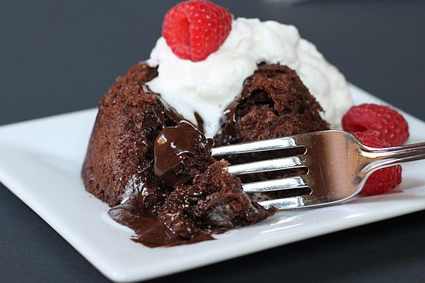Cakes may also be eaten directly from the custard cup they are cooked in (without inverting them on a plate). May also be cooked and served in half-pint mason jars.  
    (If eating cakes directly from bowl or jar, it isn't necessary to spray or coat them before adding batter and cooking.)  
      
      
      
    370 calories per lava cake